To: Professor Darish | Date: 10/06/2015
From: Trever Wagenhals | Course &Section: 16.311-802
Subject: LTSpice | Partner(s):
Subject: LTSpice | TA: Michael Masaki

SUMMARY

Become familiar with the SPICE application known as LTSpice, which allows for detailed simulation and testing of electronic circuits and components. Through this software, current, voltage, and individual component reactions under a system can be observed to confirm theoretical values match tested values.

EXPERIMENTAL APPROACH
Equipment and Materials

- Computer with internet access
- LTSpice Program
- Speakers

Procedure

Download LTSpice. Watch Tutorial 1 to become familiar with basic functions of LTSpice, such as Ohm’s Law, operating points, transient function, and DC sweep simulations. Watch Video 2 to become familiar with other basic SPICE functionality, such as Kirchoff’s current law, and voltage dividers. Watch Tutorial 3 to model an ideal op-amp circuit using a VCVS for both inverting and non-inverting amps. While watching each tutorial, the actions should be performed in LTSpice for greatest efficiency and screenshots should be taken to show work.

DISCUSSION OF RESULTS
Video 1:
The first video’s focus was the circuit shown in Figure 1. This circuit was a very simple circuit that can be analyzed simply by looking at it, but the procedure was more for understanding how the program worked than the concepts. From this circuit, numerical values for current and voltage drops were found using the DC operating point command after running the program, which output the results shown in Figure 2. Next, the transient function was used to define voltages and currents over a specific period of time. Under DC conditions, however, it should always be steady state, so for the circuit in Figure 1, it will just be a different way to view the data aside from using the OP command, shown in Figure 3. Lastly, the DC sweep command will allow for a visual representation of how the voltage will directly affect the current at any given value, giving a linear graph shown in Figure 4.
Figure 1: Video 1 Circuit 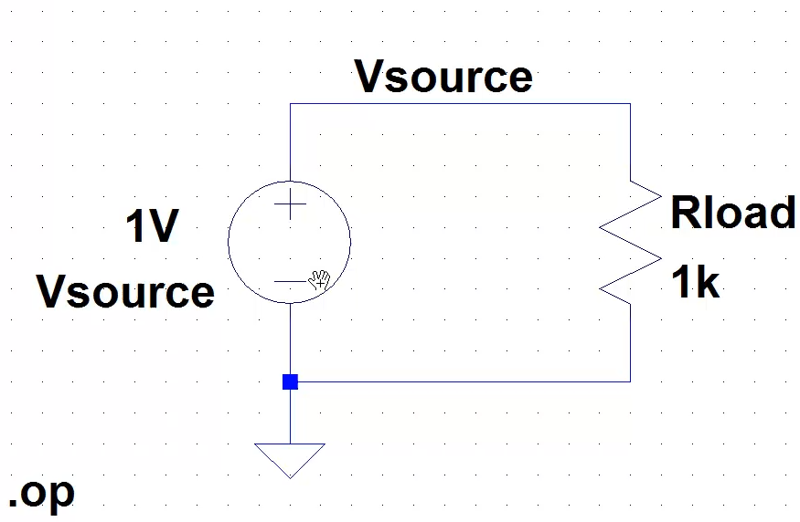
Figure 2: Operating Point Command Results
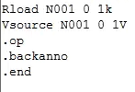
Figure 3: Transient data
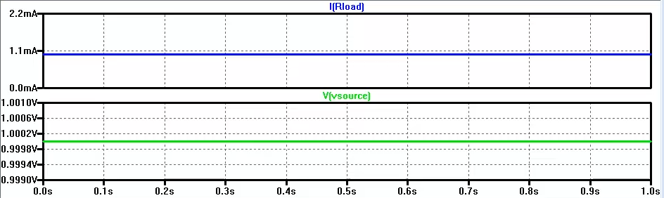

Figure 4: DC sweep
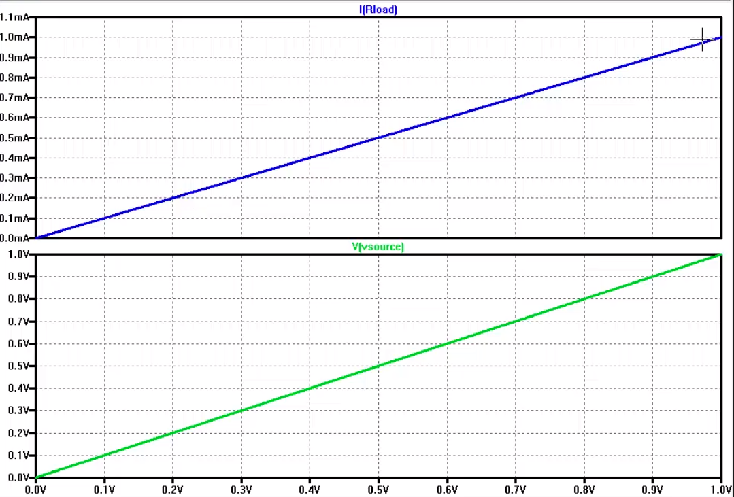

Video 2:

Video 2 started off with a quick review of the functions learned in Video 1. After, it showed how a circuit could be designed with a 0V voltage source that doesn’t affect the circuit but allows for the measurement of current across a wire at a certain point, shown in Figure 5. Next, parallel resistor voltage drop was experimented using the circuit in Figure 6. With a 9V voltage source, each resistor is expected to drop 9V, which is what is shown when the circuit was run. Figure 7 shows the concept of a virtual connection, where if two wires are given the same labeled name, then they will be in parallel and both resistors will be considered. Figure 8 combines both series and parallel resistors to get a better understanding of the voltage and current measurements in LTSpice.

Figure 5: 0V voltage source
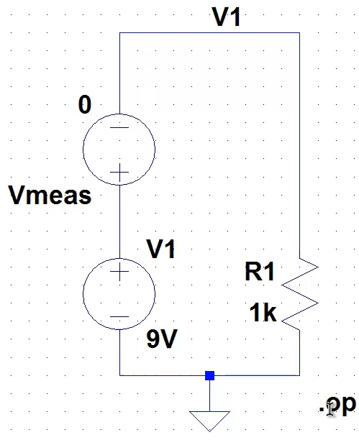

Figure 6: Parallel Resistors
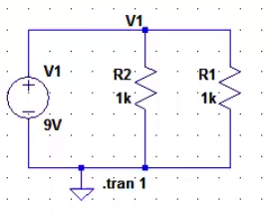
Figure 7: Virtual Connection
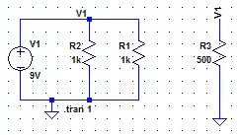

Figure 8: Parallel and Series Combination
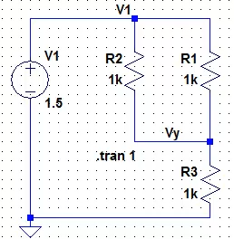

Video 3:
The last video focused entirely on op-amps and their functionality, starting with the non-inverting op-amp shown in Figure 9. This circuit has a gain of 10, given by the equation
G = RF/RG + 1 = 9k/1k + 1 = 10.
With an input of 1Vpp sinusoidal wave, the circuit can then be run to give Figure 10. The results match up with the idea of a non-inverting op-amp, where the 1Vpp becomes 10Vpp. The transient command was also run with the op-amp to show a sinusoidal wave over a specific time. With this wave, a DC offset could also be introduced so that instead of the wave starting at 0V, it will start at the offset value, showing in Figure 11, with an offset value of 1V. Next, the design of inverting amp-ops was tested. Inverting op-amps have a gain of:
G = - Rf/RG = -10k/1k = -10
The negative sign means that the sinusoidal wave will be 180 degrees out of phase from the input. The inverting op-amp is shown in Figure 12 and the output is shown in Figure 13, matching the theoretical output.
The last function tested was the pulse function, which allows to create a square wave. The square wave’s properties can be changed from how many periods there are, rise time, fall time, initial value of V, V when the signal is on, period, and number of cycles. Once the wave is established, the Vertical axis can be adjusted to get a better image of the input and output signals. The signal graphs can also be adjusted by simply adjusting the equations. So, if one ever wanted to test that their input does in fact match the output and know the gain factor, the input could be multiplied by the gain factor to get the output graph. All of these ideas are shown, combined, in Figure 14.
Figure 9: Non-inverting op-amp
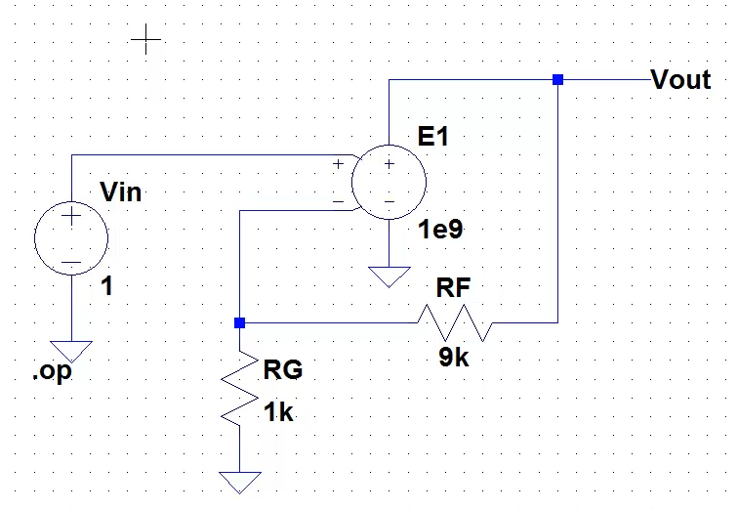
Figure 10: Output of Non-inverting amp
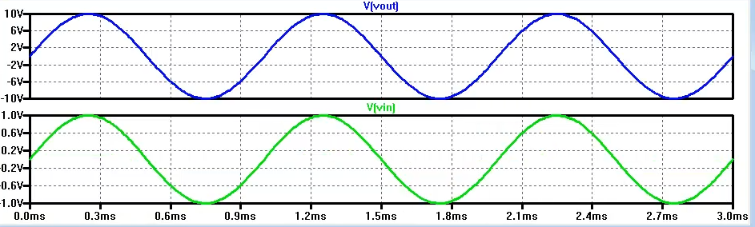
Figure 11: DC Offset and Transient time
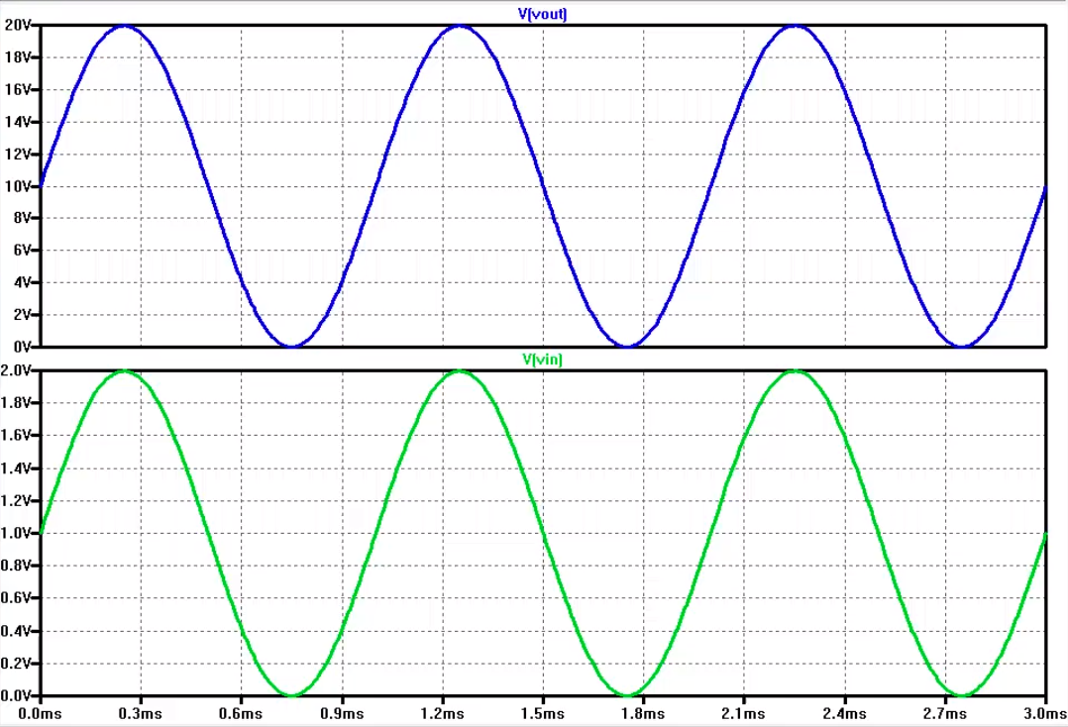
Figure 12: Inverting Op-amp
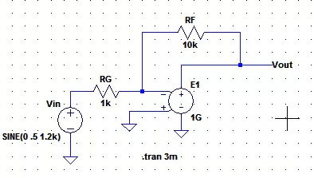
Figure 13: Inverting Op-amp output
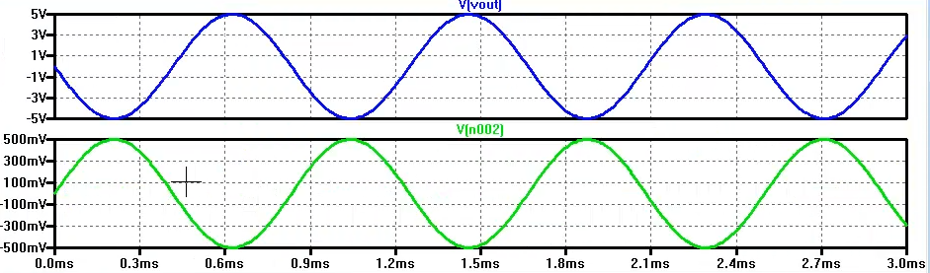
Figure 14: Pulse properties, graph adjustments, and vertical axis adjustment
